**PIZZA SALES SQL QUERIES**

**A. KPI’s**

**1. Total Revenue:**

SELECT SUM(total_price) AS Total_Revenue FROM `pizza-sales-439307.PizzaSales.PizzaSalesTable`;



**2. Average Order Value**

SELECT SUM(total_price)/COUNT(DISTINCT order_id) AS Average_Order_Value FROM `pizza-sales-439307.PizzaSales.PizzaSalesTable`;



**3. Total Pizzas Sold**

SELECT SUM(quantity) AS Total_Pizza_sold FROM `pizza-sales-439307.PizzaSales.PizzaSalesTable`;



**4. Total Orders**

SELECT COUNT(DISTINCT order_id) AS Total_Order FROM `pizza-sales-439307.PizzaSales.PizzaSalesTable`;



**5. Average Pizzas Per Order**

SELECT ROUND(CAST(SUM(quantity) AS FLOAT64)/CAST(COUNT(DISTINCT order_id) AS FLOAT64), 2) AS Avg_Pizza_Per_Order FROM `pizza-sales-439307.PizzaSales.PizzaSalesTable`;



**B. Daily Trend for Total Orders**SELECT FORMAT_DATE('%A', order_date) AS order_day, COUNT(DISTINCT order_id) AS Total_orders FROM `pizza-sales-439307.PizzaSales.PizzaSalesTable`  
GROUP BY FORMAT_DATE('%A', order_date);

***Output:***

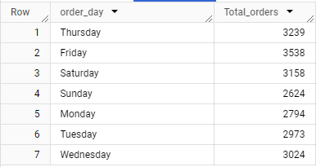

**C. Monthly Trend for Orders**

SELECT FORMAT_DATE('%B', order_date) AS Month_Name, COUNT(DISTINCT order_id) AS Total_orders FROM `pizza-sales-439307.PizzaSales.PizzaSalesTable` GROUP BY FORMAT_DATE('%B', order_date) ORDER BY Total_orders DESC;

***Output***

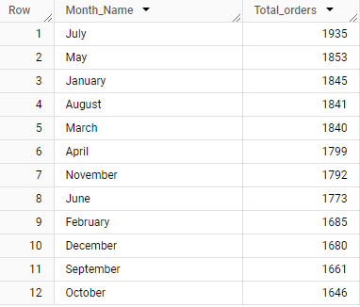

**D. % of Sales by Pizza Category**

SELECT pizza_category, ROUND(CAST(SUM(total_price) * 100 AS FLOAT64) / (SELECT CAST(SUM(total_price) AS FLOAT64) FROM `pizza-sales-439307.PizzaSales.PizzaSalesTable`),2) AS PCT FROM `pizza-sales-439307.PizzaSales.PizzaSalesTable` GROUP BY pizza_category;

***Output***

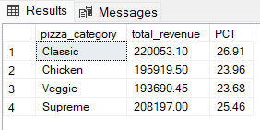

**E. % of Sales by Pizza Size**

SELECT pizza_size, ROUND(CAST(SUM(total_price) * 100 AS FLOAT64) / (SELECT CAST(SUM(total_price) AS FLOAT64) FROM `pizza-sales-439307.PizzaSales.PizzaSalesTable`),2) AS PCT FROM `pizza-sales-439307.PizzaSales.PizzaSalesTable` GROUP BY pizza_size ORDER BY PCT DESC;

***Output***

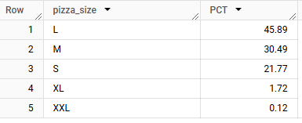

**F. Total Pizzas Sold by Pizza Category**

SELECT pizza_category,SUM(quantity) AS Total_Quantity_Sold FROM `pizza-sales-439307.PizzaSales.PizzaSalesTable` GROUP BY pizza_category ORDER BY Total_Quantity_Sold DESC;

***Output***

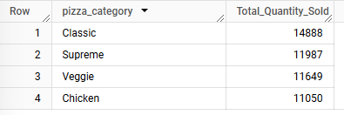

**G. Top 5 Pizzas by Revenue**

SELECT pizza_name, SUM(total_price) AS Total_Revenue FROM `pizza-sales-439307.PizzaSales.PizzaSalesTable` GROUP BY pizza_name

ORDER BY Total_Revenue DESC LIMIT 5

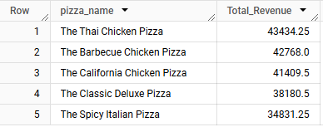

**H. Bottom 5 Pizzas by Revenue**

SELECT pizza_name, SUM(total_price) AS Total_Revenue FROM `pizza-sales-439307.PizzaSales.PizzaSalesTable` GROUP BY pizza_name

ORDER BY Total_Revenue LIMIT 5

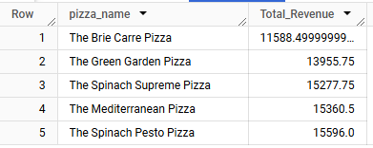

**I. Top 5 Pizzas by Quantity**

SELECT pizza_name, SUM(quantity) AS Total_Quantity_Sold FROM `pizza-sales-439307.PizzaSales.PizzaSalesTable` GROUP BY pizza_name

ORDER BY Total_Quantity_Sold DESC LIMIT 5

***Output***

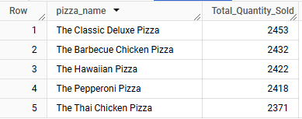

**J. Bottom 5 Pizzas by Quantity**

SELECT pizza_name, SUM(quantity) AS Total_Quantity_Sold FROM `pizza-sales-439307.PizzaSales.PizzaSalesTable` GROUP BY pizza_name

ORDER BY Total_Quantity_Sold LIMIT 5

***Output***

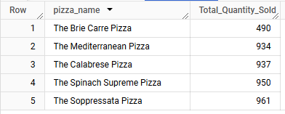

**K. Top 5 Pizzas by Total Orders**

SELECT pizza_name, COUNT(DISTINCT order_id) AS Total_Orders FROM `pizza-sales-439307.PizzaSales.PizzaSalesTable` GROUP BY pizza_name

ORDER BY Total_Orders DESC LIMIT 5

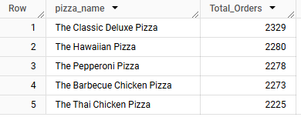

**L. Bottom 5 Pizzas by Total Orders**

SELECT pizza_name, COUNT(DISTINCT order_id) AS Total_Orders FROM `pizza-sales-439307.PizzaSales.PizzaSalesTable` GROUP BY pizza_name

ORDER BY Total_Orders LIMIT 5

